

**Inflation, employment and monetary policy in the UK and the US**

# Speech given by

David Miles, External Member of the Monetary Policy Committee, Bank of England

2013 Economic Conference of the Federal Reserve Bank of Boston 13 April 2013

I would like to thank Jochen Schanz and Arpad Morotz for research assistance, and others for helpful comments. The views expressed are my own and do not necessarily reflect those of the

Bank of England or other members of the Monetary Policy Committee.

Many central banks – and I would include both the Fed and the Bank of England in this group – follow a flexible inflation targeting regime. But the emphasis placed upon inflation relative to the weight placed upon real variables (output, employment) differs. Does this difference mean that we should expect the monetary policy of the Fed, which explicitly has a dual mandate, to be different from that of the Bank of England and the ECB which do not? I want to consider how significant might be differences in objectives in shaping monetary policy. I want to argue that in the current economic environment monetary policy may be rather insensitive to the way in which a central bank’s objectives over growth and employment sit alongside an inflation target.

At first sight, the Bank of England and the Federal Reserve seem to have rather different aims for monetary policy. The Federal Reserve Act specifies that the Board of Governors and the Federal Open Market Committee should seek ‘to promote effectively the goals of maximum employment, stable prices, and moderate long-term interest rates.’1 In contrast, the Bank of England’s remit2 puts price stability first: ‘The objectives of the Bank of England shall be: (a) to maintain price stability; and (b) subject to that, to support the economic policy of Her Majesty's Government, including its objectives for growth and employment.’

So the Bank’s remit looks lexicographic. In some ways this is misleading; the action is all in what happens when inflation is away from target. There exist tradeoffs between bringing inflation back to target very quickly and growth. Setting monetary policy to return inflation to target very fast is likely to generate a path for output and employment different from that if a more gradual return to the target was chosen. If there is a degree of hysteresis then the levels of output and employment from different monetary policy strategies might be persistently different. This is recognised by the Bank of England’s remit: ‘The framework is based on the recognition that the actual inflation rate will on occasion depart from its target as a result of shocks and disturbances. Such factors will typically move inflation away from target temporarily. Attempts to keep inflation at the inflation target in these circumstances may cause undesirable volatility in output due to the short-term trade-offs involved, and the Committee may therefore wish to allow inflation to deviate from the target temporarily.’

So the UK’s monetary policy regime is a quintessential example of a flexible inflation targeting regime. It is lexicographic only in the sense that there is an underlying belief that there is no long-run trade-off between growth and inflation. In the short-run, such trade-offs do exist. They depend on price and wage rigidities and the extent to which the economy’s supply capacity is endogenous to output growth. Monetary policy decisions during the past few years show how the Bank of England’s Monetary Policy Committee (MPC) interpreted the flexibility of its remit, and attempted to trade off inflation and growth. I suspect that the way in which the monetary policy decisions were made by the MPC is similar to how the FOMC might have reacted faced with the same economic situation. But similar is not the same as identical. Just how sensitive is

1 Federal Reserve Act, Section 2A, <http://www.federalreserve.gov/aboutthefed/section2a.htm>

2 <http://www.hm-treasury.gov.uk/d/chx_letter_to_boe_monetary_policy_framework_200313.pdf>

monetary policy to the precise preferences of the central bank (or of those that set its objectives) over inflation and economic activity?

After briefly comparing the record of the MPC and FOMC I will assess how policy might be sensitive to attaching different weights to output and the output gap in central bank objectives. I will use a simple model, calibrated to the UK economy but the main conclusion of which are relevant more widely.

**The policy response to the recession**:

The Bank of England’s initial response to the extremely sharp downturn following the financial crisis was very similar to that of the Federal Reserve. Both countries faced essentially the same problem. Figure 1 shows CPI inflation in the UK and PCE inflation for the US. In both countries, annual inflation rose above 4% in late 2008. But output contracted at the same time (Figure 2) and inflation then fell sharply. In response, both central banks cut their policy rates very substantially (Figure 3). And both subsequently engaged in asset purchases massively increasing the size of their balance sheets (Figure 4) to provide further stimulus once interest rates were close to their zero lower bound.

**Figure 1: Annual Inflation**

6

United Kingdom (CPI)

United States (PCE)

5

4

3

2

**%**

1

0

‐1

‐2

2000 2001 2002 2003 2004 2005 2006 2007 2008 2009 2010 2011 2012

Source: OECD

**Figure 2: real GDP, Q1 2007 = 100**

120

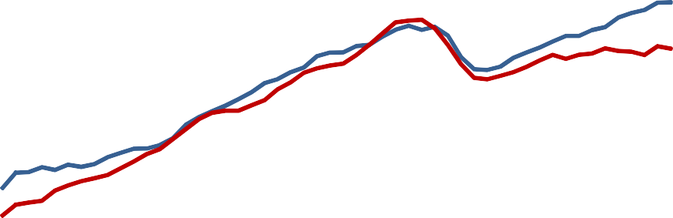

US

UK

Trend

115

110

105

100

95

90

85

80

Source: OECD

**Figure 3: FED Funds Target Rate and UK Bank Rate**

8

UK Bank rate

FED Funds Target

7

6

5

4

**%**

3

2

1

0

1995

1996

1997

1998

1999

2000

2001

2002

2003

2004

2005

2006

2007

2008

2009

2010

2011

2012

2013

**Figure 4: Size of central bank balance sheets relative to nominal GDP**

30

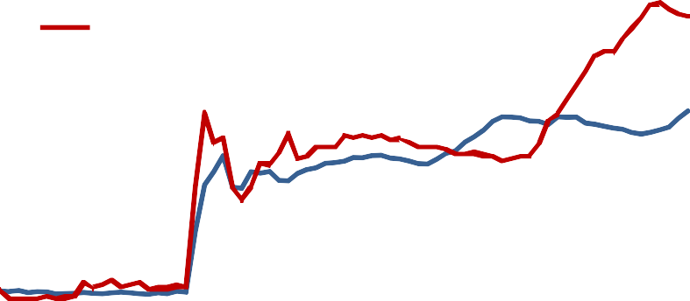

FED

BOE

25

20

15

**%**

10

5

0

2007 2008 2009 2010 2011 2012 2013

Sources: FED, BEA, BoE, ONS, IMF. Monthly balance sheet data divided by annualised nominal GDP in the relevant quarter.

* Nominal GDP forecasts from the IMF World Economic Outlook Database (October 2012 issue) have been used to estimate nominal GDP for 2013.

Differences emerged from around 2010 onwards. Output recovered less in the UK despite a stronger performance of the labour market. In contrast to the US, the labour market participation rate in the UK remained broadly flat throughout the crisis, and even picked up more recently (Figure 5). Employment in the UK rose by about 0.9 million since early 2010. As a result, the unemployment rate has remained roughly constant since mid-2009 (Figure 6). And while labour productivity continued to grow in the US, it fell in the UK, and only recently reached its pre-crisis level (Figure 7). Why we see such a comparatively strong increase in employment while output remains weak in the UK is one of the major puzzles we are facing at the moment.

**Figure 5: Participation rate**

68

US

UK

67

66

65

64

**%**

63

62

61

60

2000

2001

2001

2002

2003

2004

2005

2006

2006

2007

2008

2009

2010

2011

2011

2012

Sources: US Bureau of Labour Statistics, ONS. US data are quarterly averages of monthly data on civilian labour force participation rate of ages 16 or over. UK data are seasonally adjusted quarterly data.

**Figure 6: Harmonised unemployment rates**

12

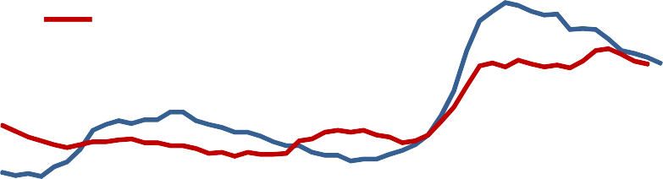

United States United Kingdom

10

8

6

**%**

4

2

0

Mar‐00

Jan‐01 Nov‐01 Sep‐02 Jul‐03 May‐04 Mar‐05 Jan‐06 Nov‐06 Sep‐07 Jul‐08 May‐09 Mar‐10 Jan‐11 Nov‐11 Sep‐12

Source: OECD

**Figure 7: Productivity (real GDP per hour, Q1 2007 = 100)**

110

US

UK

105

100

95

90

85

80

2000 2002 2004 2006 2008 2010

Sources: OECD, ONS

Since 2009, inflation has remained substantially higher in the UK than in the US, on average more than a percentage point above the Bank of England’s target of 2%. Nevertheless, the Bank of England provided further monetary stimulus, mainly by purchasing UK government bonds. The MPC anticipated that the inflation overshoot would be quite short-lived, and calibrated its policy action to bring inflation down to target towards the end of its forecast horizon two to three years later. In fact the period of above target inflation has been longer than the MPC thought. But because the Bank of England’s remit defines price stability in terms of an inflation rate, these past forecast errors did not directly impact the Committee’s decisions. (They have had a significant indirect effect arising from a concern that repeated overshoots might over time de-anchor inflation expectations.)

So, inflation has been significantly and persistently above the target level in the UK, while in the US it has stayed much closer to 2%. There is a paradox here, or at least a question: why did the Bank of England, pursuing an inflation target, adopt a monetary policy as expansionary as the Fed – which has a policy goal that explicitly gives equal weight to employment as to inflation – given that US inflation has been lower and the rise in unemployment greater?

Let me now come to the central issue: how sensitive in the current economic environment is monetary policy to the precise formulation of the central bank’s objectives? Monetary policy should depend on a wide range of economic factors: the extent to which current inflation is away from target, the likely scale of spare capacity, the degree of hysteresis in the labour market and in capital formation, the impact of monetary policy on demand and output, and the response of the economy’s supply capacity to output growth. It also depends on the relative weight on variability in inflation and on growth and employment in the objectives of those setting monetary policy. It is that dependence of monetary policy on the weights on inflation and employment

variability that I want to consider. I will do so using a simple model, which incorporates the economic relationships that I believe are crucial for monetary policy setting; and I will explicitly model central bank preferences. I am going to calibrate the model so that it is consistent with the most recent forecast for the UK made by the MPC, a forecast made with the use of a much more detailed and larger model. I suspect that many of the choices over parameters I use in my simple model would be reasonable for the US, so the results are – I think – of general interest.

**A simple model of monetary policy and monetary policy objectives**

I aim to describe the economic environment – and crucially the uncertainty about it – in a way that is roughly consistent with the assessment made by the MPC for the UK in its February 2013 *Inflation Report* but which also allows an explicit calculation to be made about what optimal monetary policy is. To do that I will need to be explicit about what monetary policy is trying to achieve. But first I want to describe how I think about risks and uncertainty. The model which I am going to use allows for four factors to be random. I am going to allow for:

* Uncertainty about how demand and output will evolve if monetary policy is left unchanged
* Uncertainty about the level of spare capacity today
* Uncertainty about how productive capacity would respond to faster (or slower) growth
* Uncertainty about how a change in monetary policy will affect demand and output

The model that I am going to use is reduced to the bare minimum3. It has three parts that describe the evolution of output, inflation and supply capacity. It can be concisely summarised in a few equations. I will assume that the relevant horizon for the policy decision taken today is three years – that is I assume that what matters is what happens to inflation and growth over the next three years. That is not because what happens after that does not matter. It is just that I want to focus on the policy setting now and for simplicity I will assume that a policy set now is left in place for some time. So I chose a time horizon long enough for that policy to have effect but not so long that the idea that policy is left there is completely unrealistic. The horizon I chose (3 years) is also that of the fan charts in the *Inflation Report* which show the MPC’s assessed probability distributions for output and inflation in the UK over the next three years. This is useful because I want the simple model to be broadly consistent with the assessment of the outlook summarised in those fan charts which are based on many more factors than in my highly simplified model.

I’ll move quite quickly through the equations and their calibration so that I can tell you sooner what monetary policy should look like according to this model and how sensitive it is to the weights the policy maker places upon inflation variability and variability in output and employment.

3 For a much fuller exposition of the model, see Miles, D (2013), *What should monetary policy do?*, Institute for Policy Research Lecture 2013, University of Bath, [http://www.bankofengland.co.uk/publications/Pages/speeches/2013/636.aspx.](http://www.bankofengland.co.uk/publications/Pages/speeches/2013/636.aspx)

The model has four equations. The first describes the impact of changes in monetary policy on the change in demand and output, y't:

*y* *t*

 ** 0

 ** 1  *M* 

This simple relation is meant to capture the marginal impact upon growth of a change in monetary policy made today and maintained over a 3 year horizon. I measure growth (y' t) as the average over the 3 year horizon and the change in monetary policy is relative to its setting at the start of that period. One should interpret the constant, (βo), as the average growth over that horizon at unchanged policy. I will treat this as a random variable, the variability of which reflects the great uncertainty about what the real growth rate would be over the next few years if monetary policy was left at its current setting. M is an index of monetary policy. The change in policy, denoted ∆M, could reflect changes in any monetary policy tools, but I have calibrated the model such that it can be interpreted as the change in the stock of asset purchases. I am assuming that right now, at the margin, the active instrument of monetary policy is asset purchases – that is quantitative easing. The coefficient {31 reflects the impact upon demand (and output) of a more expansionary policy. I treat that also a random variable – calibrated so that its average value reflects a central assessment of the effect of more asset purchases, but allowing for the possibility that more expansionary policy might have no impact on demand4.

The second equation is a backwards-looking Philips curve, which links the lagged output gap to inflation. Inflation should be thought of as domestically generated inflation. A high proportion of the theoretical literature argues that wages and labour costs depend on expected inflation. I am sceptical of the extent to which this holds in practice. Employees and their unions look at recent past, and perhaps current, inflation when they formulate their wage demands. I suspect firms do much the same in setting prices, looking at what their margin of selling price over costs is and what the market will currently bear. That is why I do not have forward-looking variables in the inflation equation, which is:

* t*  **0  **1* t*1  **2*Gapt*1

The third equation reflects a degree of hysteresis by linking the growth of the economy’s supply capacity, y' s,

t

to its actual output growth.

y' s = ISo + IS1(y't - IS2)

t

Let me be clear about this: I do not believe that monetary policy can affect supply growth in the long run. But starting from the specific situation in which we are today I believe that some of the output loss since the

4 The calibration is based on results summarised in Joyce, M, Miles, D, Scott, A, and Vayanos, D (2012), ‘Quantitative Easing and Unconventional Monetary Policy – An Introduction’, *The Economic Journal*, Vol. 122(564), pages F271-F288 and is consistent with much of the evidence on the effect of asset purchases by the Fed on the US economy.

financial crisis – relative to the trend over the longer term – is cyclical and could be regained if demand and output were to pick up again in the near future. There are several reasons. Some businesses have been unable to cut employment in line with demand without shutting down some of their operations. For others, more staff effort may be needed to produce a given level of output when demand is subdued. For example, winning and delivering work may become more resource-intensive when demand is persistently weak. And tight credit conditions are likely to have prevented resources from being put to their most productive use within the economy. If demand increases, and perceived credit risks fall, many firms should therefore be able to expand output without an increase in costs. I allow for the impact of growth in output on supply capacity to be highly uncertain and potentially to be zero.

The final equation is my attempt to translate the central bank’s objectives into a quantitative loss function. A standard specification is to let the central bank minimise over the future the expected value of the sum of the squared output gap and the squared deviation of inflation from its target. This makes sense if one assumes that supply capacity is exogenous to monetary policy. But it needs to be extended if supply is endogenous. To see this, take an extreme example and suppose that supply grows one for one with output. Then the output gap and inflation would be independent of output growth. Surely the central bank would prefer a policy that generates higher growth in this case. So I add another term to the central bank’s objective: growth in output. Here is the formal representation of the central bank’s loss function:

T

L = 心((πt - π旷)2 + λ(Gapt)2 - γy't)

t

π旷 is the target rate of inflation (which I set to 2% per annum). I’m assuming that the central bank chooses policy once and for all at the beginning of the forecast horizon, aiming to minimise this loss over its forecast horizon of T quarters.

I calibrate the model so that at unchanged policy, the frequency distributions for output and inflation generated by simulations (using 20,000 realisations for the four random variables in the system) is roughly in line with the Monetary Policy Committee’s assessed probability distributions published in its February 2013 *Inflation Report.* Figure 8 illustrates with the two probability distributions for inflation.5 When generating these distributions, I allow some data and key structural parameters of the model to be uncertain: specifically, I assume that the current extent of spare capacity, the impact of changes in monetary policy on output ({31), the growth of output in the absence of monetary policy changes ({3o), and the impact of changes in output

5 In both panels of Figure 8, the fan chart covers 90% of the distribution of outcomes for inflation. In the *Inflation Report* chart, each pair of identically coloured bands contains 10% of the outcomes. In the simpler fan chart from the stylised model, the dark blue centre covers the central 50% of the distribution. The *Inflation Report* chart is drawn assuming that Bank Rate follows implied market rates at the time the chart was produced. The market did not predict any substantial changes in Bank Rate at the time, so that the *Inflation Report* chart can be interpreted as showing outcomes for CPI inflation at approximately unchanged policy. This makes it comparable to the stylised model’s outcomes.

growth on the growth of supply capacity (IS1), are all independently and uniformly distributed over a wide range of plausible estimates.

The base case is calibrated as follows: the initial output gap (Capo) is distributed uniformly in [0 ; 3%]; the annual growth rate of supply capacity at unchanged policy (ISo) is set to 1%; the annual growth rate of output at unchanged policy ({3o) is distributed uniformly in [0 ; 3%]; the impact of a 1% change in monetary policy (that is a 1% change in the stock of asset purchases) on the growth rate of output ({31) is distributed uniformly in [0 ; 0.06%]; the impact of the deviation of the growth rate of demand from its expected value on supply capacity (IS1) is distributed uniformly in [0 ; 1]; the slope of Phillips curve (a2) is set to -0.1; inflation in the first period is set to 兀 o = 3%; the inflation inertia coefficient is set to a1 = 0.95 (this is a quarterly inertia rate; equivalent to about 0.8 for annual data); and the constant term in the inflation equation to ao = 0.1%.

**Figure 8: Forecasts of UK annual CPI inflation, *Inflation Report* and stylised model.**

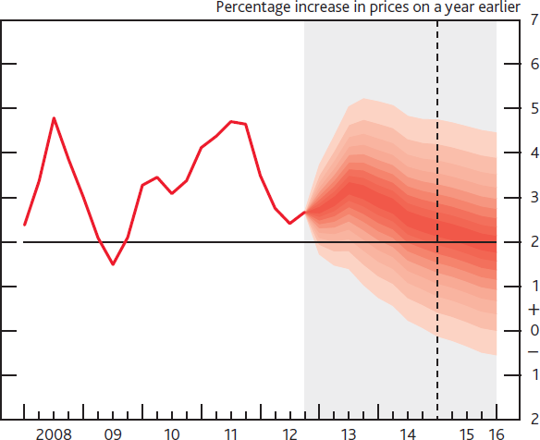

**Inflation at unchanged policy**

4%

3%

2%

1%

0%

2013Q1

2014Q1

2015Q1

2016Q1

Source: February 2013 *Inflation Report* and own calculations. The fan chart in the *Inflation Report* depicts the probability of various outcomes. It has been conditioned on the assumption that the stock of purchased assets financed by the issuance of central bank reserves remains at £375 billion throughout the forecast period. If economic circumstances identical to today’s were to prevail on 100 occasions, the MPC’s best collective judgement is that the mature estimate of GDP growth and the rate of inflation would lie within the darkest central band on only 10 of those occasions.

**Results**

Table 1 shows what the model says is the optimal setting of monetary policy to minimise the expected value of the loss function for various values of the parameters of the central bank’s objectives. The results show by how much policy should be changed from its current (April 2013) setting.

**Table 1:** Response of optimal policy to different parameterisations of the central bank’s loss function

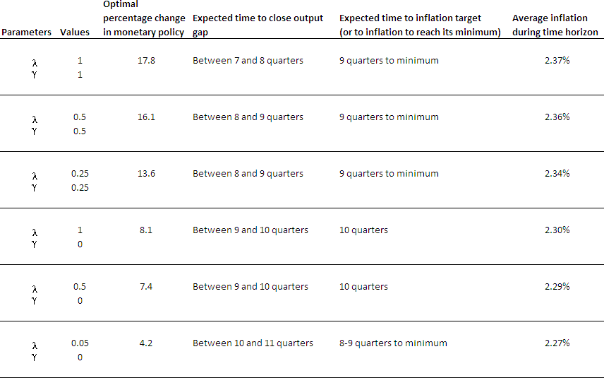

The key result from Table 1 is that optimal policy is not very sensitive to the calibration of the loss function. With a weight of one half upon both the output gap and growth (λ = 0.5; γ = 0.5) the result suggests that the Bank of England’s asset purchase programme should be extended by about 16%. For the Bank of England this would be equivalent to £60bn (about $100bn). In the context of the US, increasing asset purchases by 16% would amount to roughly $400bn: asset purchases have added around $2.5trn to the Fed’s balance sheet so far. At the current rate of $85bn per month, this would take about five months. If we increase the weight on output and set (λ = 1.0; γ = 1.0) asset purchases should be increased by about 18% – compared with 16% when those parameters were set at half that level. Perhaps a more conventional setting is to use (λ = 1.0; γ = 0.0), so that only the output gap (and not growth per se) is reflected in the central bank’s goals. In that case asset purchases should be about 8% higher than the current stock.

Micro-founded New Keynesian models tend to suggest a very low weight on the output gap, perhaps in the order of λ = 0.05.6 With that value, and no weight on the growth in output, policy should be to expand the stock of assets purchased by just over 4%.

6 E.g. Woodford (2003), *Interest and Prices: Foundations of a theory of monetary policy*, Princeton University Press.

Relative to the uncertainty calibrated in the model, which includes a great deal of uncertainty about the impact of monetary policy – and given the exceptional place from which monetary policy starts – these differences in the scale of the optimal setting for monetary policy from here are rather small. Even very large variations in the weights placed upon output and employment in the central bank’s objectives do not give dramatically different monetary policy prescriptions.

This finding seems to hold when we double the impact of the output gap on inflation (Table 1A). When we calculate optimal monetary policy starting from inflation well under target policy is much more expansionary (Table 1B), but the sensitivity of optimal policy to large variations in the weight on the output terms in the loss function remains rather low.

**Table 1A:** Response of optimal policy to different parameterisations of the central bank’s loss function when impact of output gap on inflation is doubled

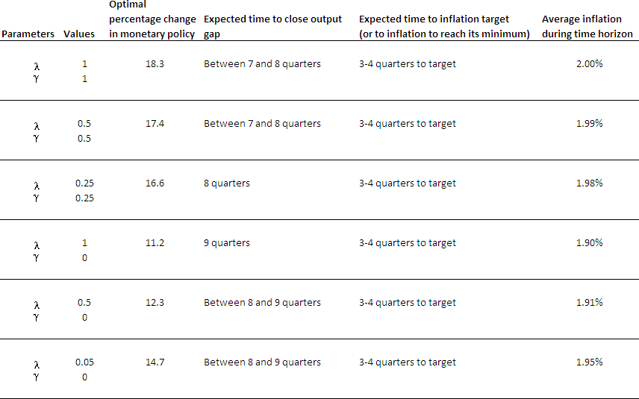

**Table 1B:** Response of optimal policy to different parameterisations of the central bank’s loss function when inflation is initially well below target (at 1%)

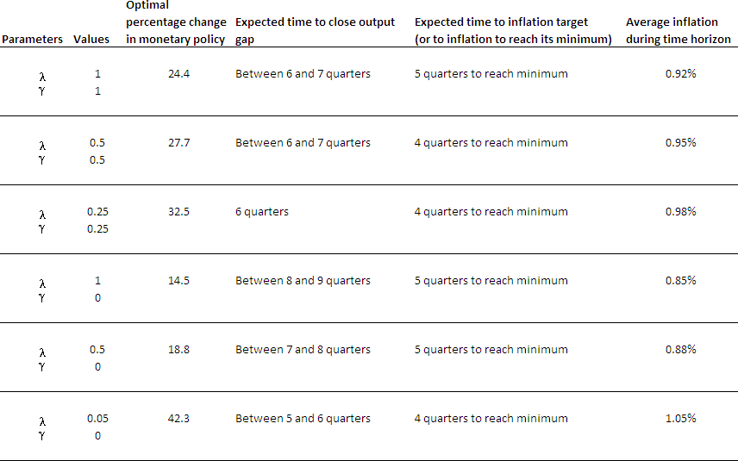

**Conclusion**

The calculations reported here are illustrative only. But they do suggest one thing. Which is that a wide range of weights placed upon real variables – output and employment – in the central bank’s objectives can today give rise to rather similar monetary policies. This is a result consistent with that found by my colleague Charlie Bean7. This might be an important part of the explanation for why the Fed and the Bank of England, two central banks with rather different formal objectives, have set monetary policy in such similar – and extraordinary – ways.

7 “The New UK Monetary Arrangements: A view from the Literature”, 1998, The Economic Journal, 108, pp 1795-1809.